**HTML | <source> src Attribute**

Last Updated : 19 Jul, 2022

The **HTML <source> src attribute** is used to specify the URL of the media resource. The source element is used as a child element of the <audio> and <video> element.

**Syntax:**

<source src="URL">

**Attribute Values:** It contains single value URL which specifies the URL of the media resource. There are two types of URL link which are listed below:

* **Absolute URL:**It points to another webpage.
* **Relative URL:** It points to other files of the same web page.

Below example illustrates the <source> src attribute in HTML:

**Example:**

* html

|  |
| --- |
| <!DOCTYPE html>  <html>    <head>      <title>          HTML source src Attribute      </title>  </head>    <body style="text-align:center;">        <h1 style="color:green;">          GeeksforGeeks      </h1>        <h2>HTML Source src Attribute</h2>        <audio controls>          <source id="mySource" src="gameover.wav"                  type="audio/mpeg">            <source src="gameover.ogg" type="audio/ogg">      </audio>  </body>    </html> |

**Output:**

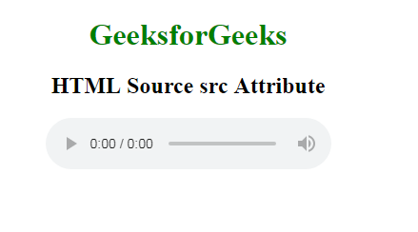

**Supported Browsers:** The browser supported by HTML <source> src attribute are listed below:

* Google Chrome
* Edge 12